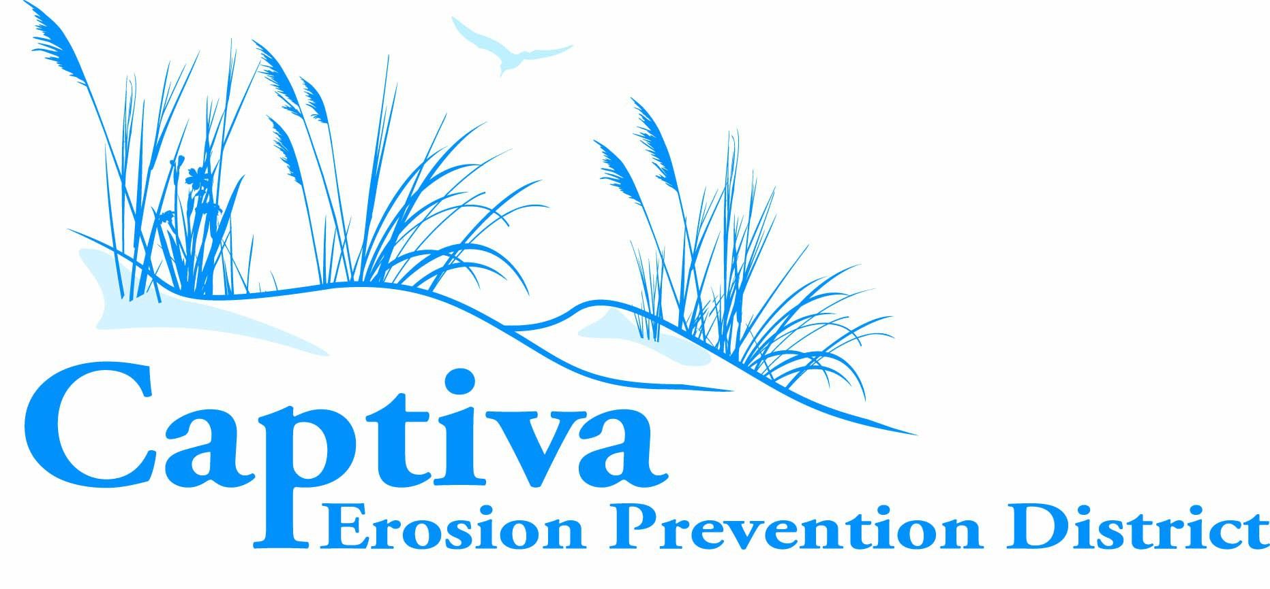 | Seat 3: Bob Walter – (C)
 | Seat 5: Timothy McGowan – (V.C.)
Board Meeting Agenda | Seat 1: John “Bernie” Dupre, Jr – (Treasurer & Secretary.)
Board Meeting Agenda | Seat 2: René Miville – (Commissioner)
September 9, 2026 – 5:01 PM | Seat 4: John Wade – (Commissioner)

Location | CEPD Office, 11528 Andy Rosse Lane, Captiva, FL 33924
Virtual Access | Zoom — Join meeting
Meeting ID | 935 6767 5111
Passcode | 770369

- Roll Call

- Changes to Agenda

- Public Comments (Unrelated to Public Hearing)

- Old Business

- Public Hearing to Review and Consider the Proposed Fiscal Year 2026-2027 Budget

- Motion to Open Public Hearing
- Public Comment and Discussion
- Motion to Close the Public Hearing
- Resolution 2026-6 Approval of Tentative Millage Rate for Fiscal Year 2026-2027
- Resolution 2026-7 Adoption of Tentative Fiscal Year 2026-2027 Budget

- Commissioners’ Comments

- Adjournment

Meeting Notice
In accordance with the Americans with Disabilities Act and section 286.26, Florida Statutes, any person requiring a reasonable accommodation to participate in this meeting should contact the CEPD office at 239.472.2472 or submit a written request to mycepd@mycepd.com. One or more elected or appointed local government officials, including but not limited to the Captiva Erosion Prevention District, may be in attendance at this meeting. Any person who decides to appeal a decision of the Board of Commissioners with respect to any matter considered at this meeting will need a record of the proceedings and, for that purpose, may need to ensure that a verbatim record of the proceedings is made, which record includes the testimony and evidence upon which the appeal is to be based. The law does not require CEPD to transcribe verbatim minutes; therefore, the person appealing must make the necessary arrangements with a private court reporter or reporting firm and bear the associated expense.

